Morphogenesis and Cell Adhesion
A body is more than a collection of randomly distributed cell types. Development involves not only the differentiation of cells, but also their organization into multicellular arrangements such as tissues and organs. When we observe the detailed anatomy of a tissue such as the neural retina of the eye, we see an intricate and precise arrangement of many types of cells. How can matter organize itself so as to create a complex structure such as a limb or an eye?
There are five major questions for embryologists who study morphogenesis:
1. How are tissues formed from populations of cells? For example, how do neural retina cells stick to other neural retina cells and not become integrated into the pigmented retina or iris cells next to them? How are the various cell types within the retina (the three distinct layers of photoreceptors, bipolar neurons, and ganglion cells) arranged so that the retina is functional?
2. How are organs constructed from tissues? The retina of the eye forms at a precise distance behind the cornea and the lens. The retina would be useless if it developed behind a bone or in the middle of the kidney. Moreover, neurons from the retina must enter the brain to innervate the regions of the brain cortex that analyze visual information. All these connections must be precisely ordered.
3. How do organs form in particular locations, and how do migrating cells reach their destinations? Eyes develop only in the head and nowhere else. What stops an eye from forming in some other area of the body? Some cells—for instance, the precursors of our pigment cells, germ cells, and blood cells—must travel long distances to reach their final destinations. How are cells instructed to travel along certain routes in our embryonic bodies, and how are they told to stop once they have reached their appropriate destinations?
4. How do organs and their cells grow, and how is their growth coordinated throughout development? The cells of all the tissues in the eye must grow in a coordinated fashion if one is to see. Some cells, including most neurons, do not divide after birth. In contrast, the intestine is constantly shedding cells, and new intestinal cells are regenerated each day. The mitotic rate of this tissue must be carefully regulated. If the intestine generated more cells than it sloughed off, it could produce tumorous outgrowths. If it produced fewer cells than it sloughed off, it would soon become nonfunctional. What controls the rate of mitosis in the intestine?
5. How do organs achieve polarity? If one were to look at a cross section of the fingers, one would see a certain organized collection of tissues—bone, cartilage, muscle, fat, dermis, epidermis, blood, and neurons. Looking at a cross section of the forearm, one would find the same collection of tissues. But they are arranged very differently in different parts of the arm. How is it that the same cell types can be arranged in different ways in different parts of the same structure?
All these questions concern aspects of cell behavior. There are two major types of cell arrangements in the embryo: epithelial cells, which are tightly connected to one another in sheets or tubes, and mesenchymal cells, which are unconnected to one another and which operate as independent units. Morphogenesis is brought about through a limited repertoire of variations in cellular processes within these two types of arrangements: (1) the direction and number of cell divisions; (2) cell shape changes; (3) cell movement; (4) cell growth; (5) cell death; and (6) changes in the composition of the cell membrane or secreted products. We will discuss the last of these considerations here.
Differential cell affinity
Many of the answers to our questions about morphogenesis involve the properties of the cell surface. The cell surface looks pretty much the same in all cell types, and many early investigators thought that the cell surface was not even a living part of the cell. We now know that each type of cell has a different set of proteins in its surfaces, and that some of these differences are responsible for forming the structure of the tissues and organs during development. Observations of fertilization and early embryonic development made by E. E. Just (1939) suggested that the cell membrane differed among cell types, but the modern analysis of morphogenesis began with the experiments of Townes and Holtfreter in 1955. Taking advantage of the discovery that amphibian tissues become dissociated into single cells when placed in alkaline solutions, they prepared single-cell suspensions from each of the three germ layers of amphibian embryos soon after the neural tube had formed. Two or more of these single-cell suspensions could be combined in various ways, and when the pH was normalized, the cells adhered to one another, forming aggregates on agar-coated petri dishes. By using embryos from species having cells of different sizes and colors, Townes and Holtfreter were able to follow the behavior of the recombined cells (Figure 3.26).
The results of their experiments were striking. First, they found that reaggregated cells become spatially segregated. That is, instead of the two cell types remaining mixed, each cell type sorts out into its own region. Thus, when epidermal (ectodermal) and mesodermal cells are brought together to form a mixed aggregate, the epidermal cells move to the periphery of the aggregate and the mesodermal cells move to the inside. In no case do the recombined cells remain randomly mixed, and in most cases, one tissue type completely envelops the other.
Second, the researchers found that the final positions of the reaggregated cells reflect their embryonic positions. The mesoderm migrates centrally with respect to the epidermis, adhering to the inner epidermal surface (Figure 3.27A). The mesoderm also migrates centrally with respect to the gut or endoderm (Figure 3.27B). However, when the three germ layers are mixed together, the endoderm separates from the ectoderm and mesoderm and is then enveloped by them (Figure 3.27C). In its final configuration, the ectoderm is on the periphery, the endoderm is internal, and the mesoderm lies in the region between them. Holtfreter interpreted this finding in terms of selective affinity. The inner surface of the ectoderm has a positive affinity for mesodermal cells and a negative affinity for the endoderm, while the mesoderm has positive affinities for both ectodermal and endodermal cells. Mimicry of normal embryonic structure by cell aggregates is also seen in the recombination of epidermis and neural plate cells (Figures 3.26 and 3.27D). The presumptive epidermal cells migrate to the periphery as before; the neural plate cells migrate inward, forming a structure reminiscent of the neural tube. When axial mesoderm (notochord) cells are added to a suspension of presumptive epidermal and presumptive neural cells, cell segregation results in an external epidermal layer, a centrally located neural tissue, and a layer of mesodermal tissue between them (Figure 3.27E). Somehow, the cells are able to sort out into their proper embryonic positions.
Such selective affinities were also noted by Boucaut (1974), who injected individual cells from specific germ layers into the body cavity of amphibian gastrulae. He found that these cells migrated back to their appropriate germ layer. Endodermal cells found positions in the host endoderm, whereas ectodermal cells were found only in host ectoderm. Thus, selective affinity appears to be important for imparting positional information to embryonic cells.
The third conclusion of Holtfreter and his colleagues was that selective affinities change during development. This should be expected, because embryonic cells do not retain a single stable relationship with other cell types. For development to occur, cells must interact differently with other cell populations at specific times. Such changes in cell affinity are extremely important in the processes of morphogenesis.
The reconstruction of aggregates from cells of later embryos of birds and mammals was accomplished by the use of the protease trypsin to dissociate the cells from one another (Moscona 1952). When the resulting single cells were mixed together in a flask and swirled so that the shear force would break any nonspecific adhesions, the cells sorted themselves out according to their cell type. In so doing, they reconstructed the organization of the original tissue (Moscona 1961; Giudice 1962). Figure 3.28 shows the “reconstruction” of skin tissue from a 15-day embryonic mouse. The skin cells are separated by proteolytic enzymes and then aggregated in a rotary culture. The epidermal cells of each aggregate migrate to the periphery, and the dermal cells migrate toward the center. In 72 hours, the epidermis has been reconstituted, a keratin layer has formed, and interactions between these tissues form hair follicles in the dermal region. Such reconstruction of complex tissues from individual cells is called histotypic aggregation.
The thermodynamic model of cell interactions
Cells, then, do not sort randomly, but can actively move to create tissue organization. What forces direct cell movement during morphogenesis? In 1964, Malcolm Steinberg proposed the differential adhesion hypothesis, a model that explained patterns of cell sorting based on thermodynamic principles. Using cells derived from trypsinized embryonic tissues, Steinberg showed that certain cell types always migrate centrally when combined with some cell types, but migrate peripherally when combined with others. Figure 3.29 illustrates the interactions between pigmented retina cells and neural retina cells. When single-cell suspensions of these two cell types are mixed together, they form aggregates of randomly arranged cells. However, after several hours, the pigmented retina cells are no longer seen on the periphery of the aggregates, and after 2 days, two distinct layers are seen, with the pigmented retina cells lying internal to the neural retina cells. Moreover, such interactions form a hierarchy (Steinberg 1970). If the final position of one cell type, A, is internal to a second cell type, B, and the final position of B is internal to a third cell type, C, then the final position of A will always be internal to C. For example, pigmented retina cells migrate internally to neural retina cells, and heart cells migrate internally to pigmented retina cells. Therefore, heart cells migrate internally to neural retina cells.
This observation led Steinberg to propose that cells interact so as to form an aggregate with the smallest interfacial free energy. In other words, the cells rearrange themselves into the most thermodynamically stable pattern. If cell types A and B have different strengths of adhesion, and if the strength of A-A connections is greater than the strength of A-B or B-B connections, sorting will occur, with the A cells becoming central. On the other hand, if the strength of A-A connections is less than or equal to the strength of A-B connections, then the aggregate will remain as a random mix of cells. Finally, if the strength of A-A connections is far greater than the strength of A-B connections—in other words, if A and B cells show essentially no adhesivity toward one another—then A cells and B cells will form separate aggregates. According to this hypothesis, the early embryo can be viewed as existing in an equilibrium state until some change in gene activity changes the cell surface molecules. The movements that result seek to restore the cells to a new equilibrium configuration.
All that is needed for sorting to occur is that cell types differ in the strengths of their adhesion. In 1996, Foty and his colleagues in Steinberg's laboratory demonstrated that this was indeed the case: the cell types that had greater surface cohesion sorted within those cells that had less surface tension (Figure 3.30; Foty et al. 1996). In the simplest form of this model, all cells could have the same type of “glue” on the cell surface. The amount of this cell surface product, or the cellular architecture that allows the substance to be differentially distributed across the surface, could cause a difference in the number of stable contacts made between cell types. In a more specific version of this model, the thermodynamic differences could be caused by different types of adhesion molecules (see Moscona 1974). When Holtfreter's studies were revisited using modern techniques, Davis and colleagues (1997) found that the tissue surface tensions of the individual germ layers were precisely those required for the sorting patterns observed both in vitro and in vivo.
Cadherins and cell adhesion
Recent evidence shows that boundaries between tissues can indeed be created both by (1) different cell types having different types of cell adhesion molecules and (2) different cell types having different amounts of cell adhesion molecules. There are several classes of molecules that can mediate cell adhesion. The major cell adhesion molecules appear to be the cadherins. As their name suggests, they are calcium-dependent adhesion molecules. Cadherins are critical for establishing and maintaining intercellular connections, and they appear to be crucial to the spatial segregation of cell types and to the organization of animal form (Takeichi 1987). Cadherins interact with other cadherins on adjacent cells, and they are anchored into the cell by a complex of proteins called catenins (Figure 3.31). The cadherin-catenin complex forms the classic adherens junctions that connect epithelial cells together. Moreover, since the catenins bind to the actin cytoskeleton of the cell, they integrate the epithelial cells together into a mechanical unit.
In vertebrate embryos, several major cadherin classes have been identified:
• E-cadherin (epithelial cadherin, also called uvomorulin and L-CAM) is expressed on all early mammalian embryonic cells, even at the 1-cell stage. Later, this molecule is restricted to epithelial tissues of embryos and adults.
• P-cadherin (placental cadherin) appears to be expressed primarily on the trophoblast cells (those placental cells of the mammalian embryo that contact the uterine wall) and on the uterine wall epithelium (Nose and Takeichi 1986). It is possible that P-cadherin facilitates the connection of the embryo to the uterus, since P-cadherin on the uterine cells is seen to contact P-cadherin on the trophoblast cells of mouse embryos (Kadokawa et al. 1989).
• N-cadherin (neural cadherin) is first seen on mesodermal cells in the gastrulating embryo as they lose their E-cadherin expression. It is also highly expressed on the cells of the developing central nervous system (Figure 3.32; Hatta and Takeichi 1986).
• EP-cadherin (C-cadherin) has been found to be critical for maintaining adhesion between the blastomeres of the Xenopus blastula and is required for the normal movements of gastrulation (Figure 3.33; Heasman et al. 1994; Lee and Gumbiner 1995).
• Protocadherins are calcium-dependent adhesion proteins that differ from the classic cadherins in that they lack connections to the cytoskeleton through catenins. Protocadherins have been found to be very important in separating the notochord from the other mesodermal tissues during Xenopus gastrulation (Chapter 10).
Cadherins join cells together by binding to the same type of cadherin on another cell. Thus, cells with E-cadherin stick best to other cells with E-cadherin, and they will sort out from cells containing N-cadherin in their membranes. This pattern is called homophilic binding. Cells expressing N-cadherin readily sort out from N-cadherin-negative cells in vitro, and univalent (Fab) antibodies against cadherins will convert a three-dimensional, histotypic aggregate of cells into a single layer of cells (Takeichi et al. 1979). Moreover, when activated E-cadherin genes are added to and expressed in cultured mouse fibroblasts (mesenchymal cells that usually do not express this protein), E-cadherin is seen on their cell surfaces, and the treated fibroblasts become tightly connected to one another (Nagafuchi et al. 1987). In fact, these cells begin acting like epithelial cells. The sorting out of cells can be explained by the amounts and types of cadherins on their cell surfaces. Fibroblasts made to express E-cadherin adhere to other E-cadherin-bearing fibroblasts, while fibroblasts made to express P-cadherin stick to other fibroblasts expressing P-cadherin (Takeichi 1987; Nose et al. 1988).
These adhesion patterns may have important consequences in the embryo. In the gastrula of the frog Xenopus, the neural tube expresses N-cadherin, while the epidermis expresses E-cadherin. Normally, these two tissues separate from each other such that the neural tube is inside the body and the epidermis covers the body (see Figure 3.32). If the epidermis is experimentally manipulated to remove its E-cadherin, the epidermal epithelium cannot hold together. If the epidermis is made to express N-cadherin, or if the neural cells are made to lose it, the neural tube will not separate from the epidermis (Figure 3.34; Detrick et al. 1990; Fujimori et al. 1990).
The amount of cadherin can also mediate the formation of embryonic structures. This was first shown to be a possibility when Steinberg and Takeichi (1994) collaborated on an experiment using two cell lines that were identical except that they synthesized different amounts of P-cadherin. When these two groups of cells were mixed, the cells that expressed more cadherin had a higher surface cohesion and sorted out within the lower-expressing group of cells. Recent studies show that differences in the degree of cell adhesion may be critical in the development of the fruit fly embryo. Within the Drosophila ovary, the developing egg, or oocyte, is always found at the most posterior side of the egg chamber, or follicle. The oocyte's nurse cells (which export messenger RNA and ribosomes into the oocyte) are found more anteriorly (Figure 3.35). This pattern reflects the distribution of E-cadherin in these cells. Although all follicle cells, nurse cells, and the oocyte express E-cadherin, the oocyte and the posterior follicle cells express it at far higher levels than the other cells (Godt and Tepass 1998; González-Reyes and St. Johnston 1998). Moreover, when E-cadherin was experimentally removed from the oocyte and nurse cells (or from the follicle cells), the position of the oocyte became random.
During development, the cadherins often work with other adhesion systems. For instance, one of the most critical times in a mammal's life is when the embryo is passing through the uterus. If development is to continue, the embryo must adhere to the uterus and embed itself in the uterine wall. That is why the first differentiation event in mammalian development distinguishes the trophoblast cells (the outer cells that bind to the uterus) from the inner cell mass (those cells that will generate the adult organism). This process occurs as the embryo travels down from the upper regions of the oviduct on its way to the uterus. The trophoblast cells are endowed with several adhesion molecules to anchor the embryo to the uterine wall. First, they contain both E-cadherins and P-cadherins (Kadokawa et al. 1989), and these cadherins recognize similar cadherins on the uterine cells. Second, they have receptors (the integrin proteins) for the collagen and the heparan sulfate glycoproteins of the uterine wall (Farach et al. 1987; Carson et al. 1988; 1993; Cross et al. 1994). Third, the trophoblast cells also have a modified glycosyltransferase enzyme that extends out from the membrane and that can bind to specific carbohydrate residues on uterine glycoproteins (Dutt et al. 1987). For something as important as the implantation of the mammalian embryo, it is not surprising that several cell adhesion systems appear to be working together.
As the psalmist said, “I am fearfully and wonderfully made.” The questions of morphogenesis remain some of the most fascinating of all developmental biology. Think, for example, of the thousands of specific connections made by the millions of cells within the human brain; or ponder the mechanisms by which the heart chambers form on the correct sides and become connected to the appropriate arteries and veins. These and other questions will be specifically addressed in later chapters.
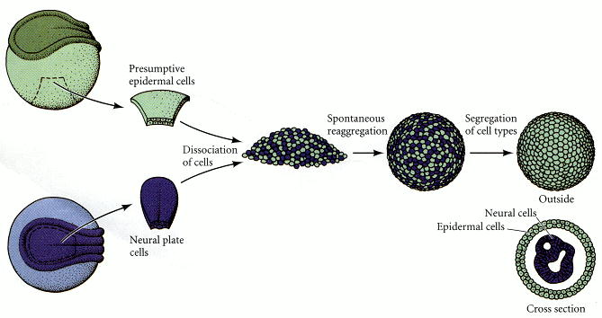
Figure 3.26. Reaggregation of cells from amphibian neurulae. Presumptive epidermal cells from pigmented embryos and neural plate cells from unpigmented embryos are dissociated and mixed together. The cells reaggregate so that one type (here, the presumptive epidermis) covers the other. (After Townes and Holtfreter 1955.)

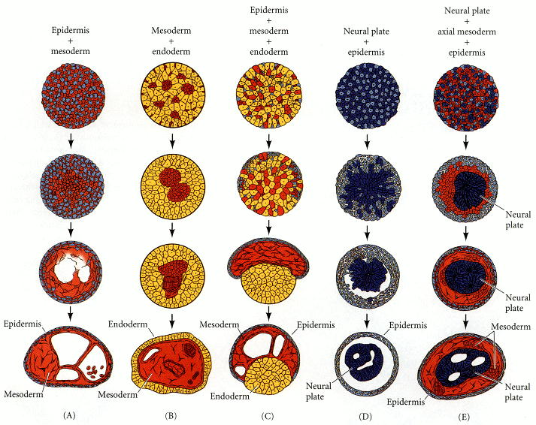
Figure 3.27. Sorting out and reconstruction of spatial relationships in aggregates of embryonic amphibian cells. (After Townes and Holtfreter 1955.)

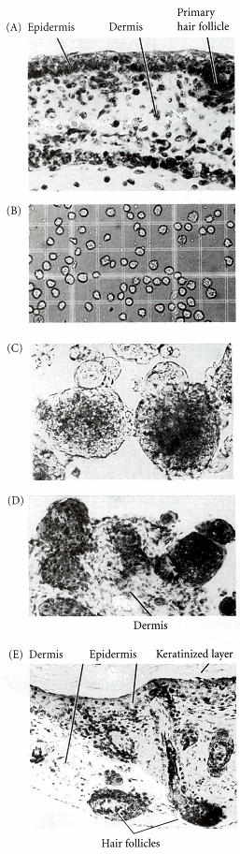
Figure 3.28. Reconstruction of skin from a suspension of skin cells from a 15-day embryonic mouse. (A) Section through intact embryonic skin, showing epidermis, dermis, and primary hair follicle. (B) Suspension of single skin cells from both the dermis and the epidermis. (C) Aggregates after 24 hours. (D) Section through an aggregate, showing migration of epidermal cells to the periphery. (E) Further differentiation of aggregates (72 hours), showing reconstituted epidermis and dermis, complete with hair follicles and keratinized layer. (From Monroy and Moscona 1979; photographs courtesy of A. Moscona.)

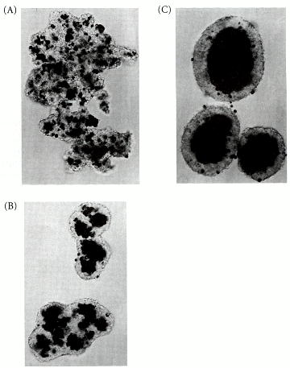
Figure 3.29. Aggregates formed by mixing 7-day-old chick embryo neural retina (unpigmented) cells with pigmented retina (dark) cells. (A) 5 hours after the single-cell suspensions are mixed, aggregates of randomly distributed cells are seen. (B) At 19 hours, the pigmented retina cells are no longer seen on the periphery. (C) At 2 days, a great majority of the pigmented retina cells are located in a central internal mass, surrounded by the neural retina cells. (The scattered pigmented cells are probably dead cells.) (From Armstrong 1989; photographs courtesy of P. B. Armstrong.)

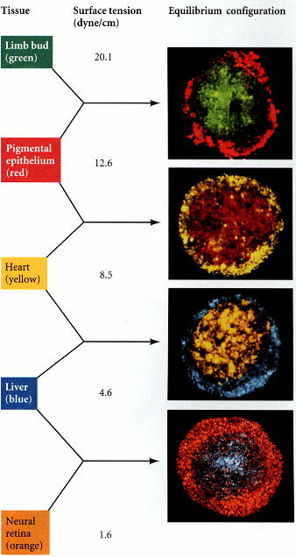
Figure 3.30. Hierarchy of cell sorting in order of decreasing surface tensions. The equilibrium configuration reflected the strength of cell cohesion, with the cell types having the more cell cohesion segregating inside the cells with less cohesion. The images were obtained by sectioning the aggregates and assigning colors to the cell types by computer. The black areas represent cells whose signal was edited out in the program of image optimization. (From Foty et al. 1996; photograph courtesy of M. S. Steinberg and R. A. Foty.)

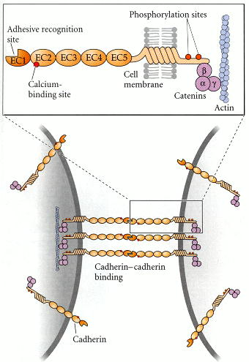
Figure 3.31. Schematic representation of cadherin-mediated cell adhesion. Cadherins are associated with three types of catenins. The catenins can become associated with the actin microfilament system within the cell. (After Takeichi 1991.)

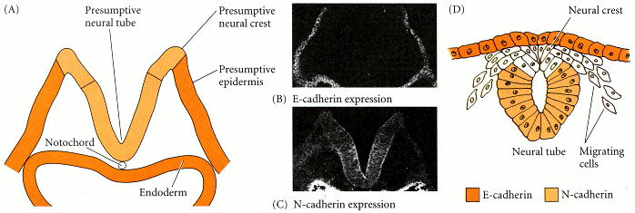
Figure 3.32. Localization of two different cadherins during the formation of the mouse neural tube. (A) Double immunofluorescent staining was used to localize E-cadherin (B) and N-cadherin (C) in the same transverse section of an 8.5-day embryonic mouse hindbrain. Antibodies to E-cadherin were labeled with one type of fluorescent dye (which fluoresces under one set of wavelengths), while antibodies to N-cadherin were marked with a second type of fluorescent dye (which emits its color at other wavelengths). Photographs taken at the different wavelengths reveal that the outer ectoderm expresses predominantly E-cadherin, while the invaginating neural plate ceases E-cadherin expression and instead expresses N-cadherin. (D) When the neural tube has formed, it expresses N-cadherin, the epidermis expresses E-cadherin, and the neural crest cells between them express neither. (B, C photographs by K. Shimamura and H. Matsunami, courtesy of M. Takeichi; D after Rutishauser et al. 1988.)

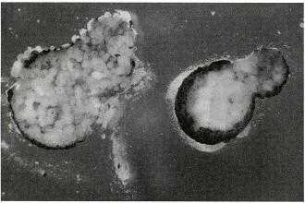
Figure 3.33. The importance of cadherins for maintaining cohesion between developing cells can be demonstrated by interfering with their production. When oocytes are injected with an antisense oligonucleotide against a maternally inherited cadherin mRNA (thus preventing the synthesis of the cadherin), the inner cells of the resulting embryo disperse when the animal cap is removed (left). In control embryos (right), the inner cells remain together. (After Heasman et al. 1994; photograph courtesy of J. Heasman.)

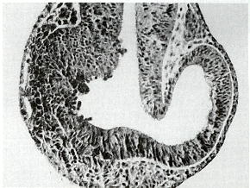
Figure 3.34. The importance of N-cadherin in the separation of neural and epidermal ectoderm. At the 4-cell stage, the blastomeres that form the left side of the Xenopus embryo were injected with an mRNA for N-cadherin that lacks the extracellular region of the cadherin. This mutation blocks N-cadherin function. During neurulation, the cells with the mutant protein did not form a coherent layer distinct from the epidermis. (From Kintner et al. 1992; photograph courtesy of C. Kintner.)

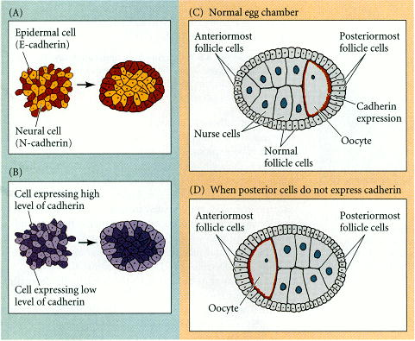
Figure 3.35. Cell sorting out in vivo: Drosophila oocytes. (A, B) Molecular bases for sorting. (A) Cells having different types of cadherins can sort from each other. (B) Cells having different amounts of cadherins can sort from each other. In both cases, those with the highest surface tension sort inward from those with less surface tension. (C, D) Sorting out in the Drosophila ovary caused by differential E-cadherin expression. (C) Normal egg chamber, with the oocyte positioned posteriorly and the nurse cells more anteriorly. This pattern is a consequence of the posterior follicle cells and the oocyte expressing higher levels of E-cadherin than any other cell in the field. (D) When the anterior follicle cells are induced to express more E-cadherin, the oocyte is positioned at the anterior pole. This disturbs axis formation in the fly embryo. (After Peifer 1998.)

